

Initial Assessment and Referral (IAR) Guidance for Mental Health
Part A – General Guidance
Version 2.0
May 2024

Initial Assessment and Referral Guidance for Mental Health, Part A – General Guidance
Copyright
© 2024 Commonwealth of Australia as represented by the Department of Health and Aged Care
This work is copyright. You may copy, print, download, display and reproduce the whole or part of this work in unaltered form for your own personal use or, if you are part of an organisation, for internal use within your organisation, but only if you or your organisation:
(a) do not use the copy or reproduction for any commercial purpose; and
(b) retain this copyright notice and all disclaimer notices as part of that copy or reproduction.
Apart from rights as permitted by the Copyright Act 1968 (Cth) or allowed by this copyright notice, all other rights are reserved, including (but not limited to) all commercial rights.
Requests and inquiries concerning reproduction and other rights to use are to be sent to the Communication Branch, Department of Health and Aged Care, GPO Box 9848, Canberra ACT 2601, or via e-mail to copyright@health.gov.au.
Permitted Uses
You may download, display, print, and reproduce the whole or part of this publication in unaltered form for:
- your own personal use;
- use within your organisation; or
- distribution and sharing with third parties.
but only if:
- you or your organisation do not use or reproduce the publication for any commercial purpose; and
- if reproduced, this copyright notice and all disclaimer notices are included as part of any reproduction.
Enquiries regarding use of this publication should be addressed to MH.IARProject@health.gov.au
This licence does not cover, and there is no permission given for, use of the Commonwealth Coat of Arms or any logos and trademarks (including the logo of the Department of Health).
Disclaimer
Use of this publication is not a substitute for professional knowledge and clinical judgement. Systems and processes for initial assessment and referral should consider the unique and personal circumstances of the individual client, including other health or social issues, their preferences and choices, and any risk or safety issues.
Use of this publication is at your own risk, and you must make your own assessment of its appropriateness for the environment and circumstances in which it is to be applied. The Department of Health assumes no legal liability or responsibility to anyone for the consequences of using or relying on the information included or incorporated in this publication.
This publication contains links to external websites that the Department of Health has no direct control over. It is the responsibility of users to make their own decisions about the accuracy, currency, reliability, and completeness of information contained on linked websites.
The contents of this publication may be updated from time to time and users are encouraged to regularly visit IAR-DST to check for updated versions of this publication.

Note on intended users
The Initial Assessment and Referral (IAR) Guidance for Mental Health and IAR Decision Support Tool (IAR-DST) is designed for use by Australian health professionals when a person presents to primary care for assistance for their mental health, or when the health professional providing the service identifies the person may be experiencing possible mental health symptoms and/or psychological distress. The IAR is intended to assist Australian health professionals to decide the most appropriate level of care a patient will need across five levels of care in an Australian stepped care model.
The IAR Guidance documentation provides key information for Australian health professionals who undertake assessment and referral of people presenting to primary care who may have a mental health need.
It also provides information for mental health policy, program and service designers, and mental health and primary care service providers considering embedding the IAR into their systems, processes, and services.
Widespread adoption of the IAR 8 domain assessment framework and level of care model in the Australian healthcare system will aid in consistency of assessment and communication of patient information between practitioners, services, and systems.

Terms of use
As a condition of Your use of the Online Decision Support Tool and its documentation and guidance material (IAR Guidance), You must agree to these Terms of Use each time you use the Online Decision Support Tool and IAR Guidance. The use of this Part is subject to the Terms of Use.

About the IAR Guidance documentation and IAR-Decision Support Tool
The Initial Assessment and Referral for Mental Health (IAR) comprises the online IAR Decision Support Tool (IAR-DST) and Guidance documentation.
The IAR Guidance documentation includes a suite of documents providing information about the IAR and how to use it appropriately and effectively with people of different ages who present to the Australian primary care system with mental health symptoms and/or psychological distress.
This document, the Initial Assessment and Referral Guidance for Mental Health – PART A – General Guidance, provides information on the IAR relevant to all age groups. It articulates the principles guiding the use of the IAR 8 domain assessment framework and IAR-DST to determine or confirm the most appropriate level of mental health treatment/care a patient requires, based on their current symptoms and circumstances. It provides information about the IAR five levels of care (see Levels of Care) in the primary mental health care system and the types of services and supports associated with each level of care. It also provides general information about the online IAR-DST available at https://iar-dst.online/#/.
Detailed information on the 8 domains and how to rate each domain for children, adolescents, adults, and older adults is contained in the IAR Assessment Domains and Rating Guide for each age group, available as follows:
- Part B - Children (aged 5-11)
- Part C - Adolescents (aged 12-17)
- Part D – Adults (aged 18-64)
- Part E – Older Adults (aged 65 and over)
Whilst the IAR Guidance documentation uses age to indicate the overall appropriateness of each rating guide, the final decision about the most appropriate rating guide to use with each person is based on the clinical judgment of the user, considering contextual and developmental factors.

Contents
Note on intended users 3
Terms of use 3
About the IAR Guidance documentation and IAR-Decision Support Tool 3
Contents 4
Table of Figures 5
Table of Practice Points 5
A note on language 6
Introduction 8
Objectives of the IAR Guidance documentation and IAR-DST 8
Acknowledgements 9
Feedback 9
Purpose and Scope of the IAR 10
A framework for assessment 10
Focus on current mental health treatment needs 10
Supporting clinical judgement 10
IAR users and target population 10
Appropriate use of the IAR 11
Initial assessment in mental health 11
Understanding the IAR domains and levels of care 13
The 8 domains 13
The IAR levels of care 14
Level 1 - Self-Management: 16
Level 2 - Low-Intensity Services 18
Level 3 – Moderate-Intensity Services 19
Level 4 – High-Intensity Services 20
Level 5 - Acute and Specialist Community Mental Health Services 22
Guiding Principles for initial assessment and referral 24
1. Supported decision-making and consumer choice 24
2. Trauma-informed initial assessment and referral practices 24
3. Least treatment burden for best outcome 25
4. Accessible care options 25
5. Responsive and flexible 25
6. Effective clinical governance and safety 25
Progress Monitoring and Review 26
The IAR decision support tool logic 27
The online IAR tool 31
Accessing the online tool 31
Key features of the online tool 31
Integration of the online tool 31
Application Programming Interface (API) 31
Reference Implementation and Test Data Set 32
Digital Decision Support Tools – Conditions of use 32
More information 32

Table of Figures
Figure 1: the IAR domains 13
Figure 2: the 5 IAR levels of care and mental health and community support needs 15
Figure 3: Mapping assessments on 8 interactive domains to 5 levels of care 27
Figure 4: IAR-DST Logic for Children and Adolescents 29
Figure 5: IAR-DST Logic for Adults and Older Adults 30

Table of Practice Points
Practice point – rapport and trust 12
Practice point – informed consent 12
Practice point – involving the patient and carer in decision-making 16
Practice point – routine monitoring 26

A note on language
Mental health systems and services include many diverse terms and phrases that refer to people, roles, and processes. This document recognises that preferred terminology in mental health may vary from both the terms in policy documents and the terms other people prefer. Not all of the terms used have commonly agreed definitions, and not all readers will identify with the use of labels in the same way as they are presented here.
For clarity, and applicable across the suite of IAR guidance documentation and the IAR-DST, the following terms are used and defined as:
Adolescent | A person aged between 12-17 years.
Adult | A person aged between 18-64 years.
Carers | People, often family members, who provide, or have provided in the past, ongoing personal care, support, advocacy and/or assistance to a person with mental illness.
Child | A person aged between 5-11 years.
Clinician/Health Professional/Practitioner | These terms are used interchangeably in this document and includes all those professionals listed in the Appropriate use of the IAR section of this document.
Decision Support Tool | A tool designed to provide an evidence-informed framework for structuring the assessment of individuals seeking or requiring mental healthcare and for determining the intensity of intervention, i.e., the most appropriate level of care, each person requires.
IAR descriptors | Each of the IAR 8 domains include descriptors under each domain. The descriptors provide examples of problems that could be present and are indicative of each severity level (there are five severity levels: no problem in this domain, mild, moderate, severe, or very severe problem in this domain). The descriptors provided are examples only, not an exhaustive list of all factors relevant to the domain. The descriptors at each severity level are differentiated by several factors, including the size or magnitude of the symptoms being experienced, the recency and frequency of occurrence of the symptoms and the pervasiveness of the impact of the symptoms on areas of the person’s life.
Domain | An area for assessment. There are 8 domains in the IAR (refer to The 8 domains).
Initial Assessment and Referral (IAR) | A collective term for both the IAR-DST and Guidance documentation.
IAR Decision Support Tool (IAR-DST) | The online tool that allows individual practitioners to enter the 8 domain ratings and view the derived level of care outcome online.
IAR Guidance | This document, and other parts thereof (i.e., Parts A, B, C, D and E) as well as other associated documentation detailing the use and context of the IAR.
Older Adult | A person aged 65 years and over.
Parent/guardian | Any person who has assumed responsibility for the care and custody of a child or upon whom there is a legal duty for such care.
Patient  Consumer  Person with lived or living experience of mental illness  Person presenting with mental health symptoms and/or psychological distress | A range of terms are used to describe a person presenting with mental health symptoms and/or psychological distress. In many instances in this document, the term patient is used as this is the common terminology used by health practitioners in primary care. At other times, consumer is used and refers to people who identify as having a living or lived experience of mental illness, irrespective of whether they have a formal diagnosis, have accessed services and/or received treatment. This includes people who describe themselves as a ’peer’, ‘survivor’ and ’expert by experience’.
Practice point | Provided throughout this document, as useful aids to provide more detailed, relevant information or context.
Primary care | Often the first contact a person has with the health system and can be delivered in a range of settings, by a range of providers. The majority of primary care services are provided by general practitioners (GPs) within general practice or in an aged care or community setting, by public or private service providers. Nursing care, midwifery, pharmacy, dentistry, Aboriginal health services, and allied health care are also examples of primary care services.
Rating | A classification of someone’s circumstances, symptoms, and other environmental factors for each domain in the IAR-DST.
Rating Guide | Rating Guides are specific to the age cohorts for assessment. There are 4 IAR Rating Guides (Parts B, C, D and E of the IAR Guidance) available:  - Children (aged 5-11) – Part B  - Adolescents (aged 12-17) – Part C  - Adults (aged 18-64) – Part D  - Older Adults (aged 65 and over) – Part E
Red flag | Factors that would usually warrant referral to IAR Level 5 care, including acute and specialist community mental health services. These include very severe ratings on symptoms, risk, and functioning domains. In the IAR-DST logic, ‘red flag’ items act as independent criteria that automatically place an individual in a specific level of care, regardless of their assessment on other domains.
User | A health professional or non-clinician working within the Australian health system who is using the IAR to assist with determining the most appropriate level of mental health care a person presenting with a mental health need requires.

Introduction
The IAR is an Australian Government initiative, implemented by the Department of Health and Aged Care (the Department). The Department provides the IAR Guidance documentation and the IAR-DST as well as training on the IAR and a range of supporting resources those using the IAR may find helpful.
The IAR Guidance documentation includes information and advice about initial assessment and referral for people presenting to primary care for assistance for their mental health, or when the health professional providing the service identifies the person may be experiencing possible mental health symptoms and/or psychological distress. The IAR is not designed to be used as a general population screening tool.
There are separate rating guides available for use with:
- Children (aged 5-11)
- Adolescents (aged 12-17)
- Adults (aged 18-64)
- Older Adults (aged 65 and over)
Whilst the IAR Guidance uses age to indicate the overall appropriateness of each rating guide, the final decision about the most appropriate rating guide to use with each patient is based on the clinical judgment of the user, considering contextual and developmental factors.
The online IAR-DST (https://iar-dst.online/#/) enables users to select the most appropriate rating guide to use with the person presenting to primary care for mental health initial assessment and referral. The online IAR-DST converts assessment ratings on each of the 8 domains, using decision logic outlined in this document, to recommend a level of care for consideration by the health professional.

Objectives of the IAR Guidance documentation and IAR-DST
The IAR-DST and Guidance documentation is based on Australian and international evidence and has been informed by advice from Australian health professionals, researchers, policy makers and people with lived experience of mental illness and their carers.
The objectives of the IAR Guidance are to:
- assist Australian health professionals to decide or confirm the most appropriate level of mental health treatment/care a patient requires, based on their current symptoms and circumstances, across the five levels of care in the Australian primary mental health stepped care model, i.e., the least intensive and least intrusive evidence-based intervention that will likely lead to the most significant possible gain or improvement for the person.
- provide a framework to guide mental health assessment across 8 domains. The 8 domains help distil essential assessment information and amplify key signals critical for decision-making and planning of mental health treatment and appropriate referrals and supports.
- provide a nationally consistent decision support tool to help referrers communicate initial assessment and referral information and articulate treatment needs using language commonly understood across the Australian health care system; and
- complement, but not replace, health professional’s clinical judgement and patient preferences and choices.
In the Australian stepped care approach to mental health, a person presenting to the health system is ideally assessed and referred to the level of care that best meets their needs, rather than a service that is less intensive than required, known as under-servicing, or more intensive than required, known as over-servicing. Under-servicing brings risks that patients will experience poorer outcomes, including a deterioration of their mental health and find the help offered ineffective, potentially negatively impacting their attitudes towards help-seeking. Over-servicing can also lead to poorer outcomes for patients, such as feeling an unnecessary burden of care, potentially impacting motivation, and attitudes towards help-seeking. Under or over-serving is also an inefficient use of health system resources, increasing costs, extending patient’s episodes of care, and contributing to bottlenecks in the system.
It is important to note that the IAR-DST assists with the identification of the most appropriate level of mental health treatment/care each person requires within the stepped care model. Some people experiencing mental health symptoms and/or psychological distress are likely to need a range of other supports in addition to intervention for their mental health symptoms and distress. Many of these services and supports are provided outside the mental health system, for example, housing, financial assistance and drug and alcohol services or may be informal, such as social groups. The IAR levels of care definitions do not apply to these services. Health professionals should use their clinical judgement and knowledge of local services to discuss appropriate options for support with the patient.

Acknowledgements
The Department would like to thank working group members and Expert Advisory Group (EAG) members for their contributions to the development of the IAR since 2017. Over 40 members with expertise in mental health, including people with lived experience and carers, have contributed their time, experience, and expertise.

Feedback
The development of the IAR Guidance and IAR-DST has been informed by national and international evidence and informed by experts in mental health, including people with lived experience and carers.
The Department welcomes feedback on the IAR and encourages research into its use and sharing of outcomes with the Department. If you would like to discuss research involving the IAR-DST and/or IAR Guidance, you can contact the Department at MH.IARProject@Health.gov.au.
If you would like to provide feedback on the IAR-DST and IAR Guidance, you can do so via IAR-DST Feedback.

Purpose and Scope of the IAR
The IAR-DST provides an evidence-informed framework for structuring a holistic assessment of individuals seeking or requiring mental healthcare and a process and tool for determining the intensity of intervention, i.e., the most appropriate level of care, each person requires.

A framework for assessment
The IAR provides a framework using 8 domains to organise the critical observations made during an initial mental health assessment. It is this assessment that is then converted into a rating (using the rating guide for each domain) and input into the IAR-DST to determine a recommended level of care.
The expectation is that healthcare professionals using the IAR provide contextually, developmentally, and culturally appropriate assessments. The domains reflect areas that are covered in a typical mental health assessment. It is recommended that assessment include an exploration of all 8 domains. Note, if the patient has had an assessment undertaken recently (for example by the referring practitioner or service), there may be no need to reassess all the 8 domains in depth and assessment can focus on confirming understanding and identifying any factors that have changed since the prior assessment. Clinical judgement and patient engagement and preferences should be considered.
The model of care in place at each service and nature of the individual’s circumstances may also impact the depth of exploration undertaken in each domain and how the assessment is conducted.

Focus on current mental health treatment needs
The IAR-DST is used at a point in time. That point is when a person seeks or requires mental health assistance. In general, assessment in each domain explores what has been ‘typical’ for the person over the past 30 days. However, if the person has experienced recent or sudden changes or deterioration in a domain area, the assessment should elicit this information and the rating given for the person on the relevant domain should be based on the current situation, not what has been typical over the previous 30 days.
The IAR rating descriptions for each domain prompt users to look back further than 30 days where it is critical to do so (e.g., lifetime experience of suicide attempts and previous mental health treatment history). The IAR does not predict the future course of the condition or treatment outcome.

Supporting clinical judgement
The IAR is not a substitute for professional knowledge and clinical judgement. While the 8 domains guide the areas that should be considered in a typical mental health assessment, the actual assessment procedures are guided by the healthcare professional, the service model, and the patient.

IAR users and target population
Whilst the IAR uses age to indicate the overall appropriateness of the child, adolescent, adult and older adult rating guides, the final decision about the most appropriate rating guide to use with each patient is based on the clinical judgment of the user, considering contextual and developmental factors. This includes examining how the individual is functioning on a social, physical, intellectual, cultural and emotional level and whether this is at, below or higher than what is typical for their chronological age.
The Department acknowledges that the IAR does not specifically address the needs of a range of priority population groups, including First Nations Australians, people from culturally and linguistically diverse backgrounds, and veterans. Consultation with representatives from these populations is planned to determine how best to support mental health initial assessment and referral with people from these groups.
In the interim, users of the IAR will need to consider the requirements for high-quality initial assessment and referral processes for these population groups.

Appropriate use of the IAR
Initial assessment should be undertaken by a health professional who is suitably qualified and experienced in mental health assessments and treatment with the specific population where the IAR is being used (for example, children, adolescents, adults and older adults and priority population groups). Suitably qualified and experienced professionals generally include:
- General Practitioners (GPs) and other medical specialists, nurse practitioners and other clinicians trained in mental health
- Psychologists
- Mental health social workers who are members of the Australian Association of Social Workers (AASW) and certified by AASW as meeting the practice standards for mental health social workers
- Aboriginal and Torres Strait Islander Health Practitioners, Aboriginal health practitioners, Torres Strait Islander health practitioners, Aboriginal and Torres Strait Islander Health Workers and Aboriginal and Torres Strait Islander mental health workers trained in mental health and social and emotional wellbeing
- Psychiatrists
- Credentialled mental health nurses (specialist nurses who have been credentialled against the Australian College of Mental Health Nurses’ credentialing criteria in relation to registration, education, practice experience, professional development, and professional integrity)
- Occupational therapists who are accredited by Occupational Therapy Australia as having a minimum of two years experience in mental health and who adhere to the Australian Competency Standards for Occupational Therapists in Mental Health
It may be appropriate to engage staff other than those listed above (i.e., non-clinical staff such as peer workers, youth workers, community support workers) in undertaking assessment and completing the IAR-DST to obtain a recommended level of care. Where non-clinical staff are involved in the initial assessment process, service providers should ensure that service models and delivery of care adhere to the relevant healthcare standards and:
- Systems and processes, including clinical governance, are in place to deliver safe and high-quality care
- Staff are adequately trained in mental health assessment and referral
- Suitably qualified and experienced mental health clinicians oversee decision-making by non-clinical staff. Key decision-making points during the IAR process include:
  - decisions about the rating on each of the domains, and
  - the decision about the most appropriate level of care a patient should be referred to
- Non-clinical staff have immediate access to supervision from a suitably qualified and experienced clinician (e.g., whenever it is needed, via telephone or onsite supervision).

Initial assessment in mental health
The IAR is designed to assist assessment and referral discussions and decisions when a person presents in the primary care system with mental health symptoms and/or psychological distress or when the health professional providing the service identifies the person may be experiencing possible mental health symptoms and/or psychological distress. It was not specifically designed as a tool for re-assessment or monitoring of a person accessing interventions for their mental health.
The aim of the IAR is to assist clinicians with collecting sufficient social, health and clinical information about the person presenting with mental health symptoms and/or psychological distress to determine whether there is a need for further assessment or intervention, and the level of intervention or care required (i.e., the appropriate level from the stepped care model for primary mental health care).
The IAR-DST does not determine the urgency of the response required, however, when undertaking an assessment and seeking to complete an IAR, if the clinician judges that there are significant risks to the person and urgent intervention is required, the IAR assessment process should be abandoned and service protocols and procedures for urgent assessment and care pathways should be activated. This is outlined in each of the IAR Rating Guides in the sections on Domain 2: Harm.
Ideally, the key findings of the assessment form the basis of the referral information shared with the referral service so that any further assessment that needs to be completed can build upon the information already provided, minimising the assessment burden on the person.
Practice point – rapport and trust
Services must be confident that initial assessment is conducted by staff with experience in building rapport and trust with people experiencing mental health symptoms and/or psychological distress. The validity of the initial assessment outcome may be compromised if the person is reluctant or unable to provide or disclose the information needed. Parents, family members and peers may also be of significant value when actively engaged and encouraged to support the person and clinician to gain a supportive and trusting relationship.

Practice point – informed consent
Clinicians have legal and ethical obligations to obtain informed consent before performing any healthcare intervention. To give informed consent, a person (or the person making decisions for them if they cannot make decisions for themselves) should be sufficiently informed of the risks and benefits of any treatment (including, where relevant, the risk associated with no treatment).
The process of gaining consent for the treatment of children and adolescents (under the age of 18) differs significantly from that of adults and is more complex and varied. In some instances, consent must be given by the relevant parent or guardian, whereas in others, it may be possible for a person under 18 who is a ‘mature minor’ to give consent. A mature minor is a child or adolescent assessed as having the capacity to make specific decisions based on various factors, including the nature of the treatment, age, maturity, medical/social history, degree of independence, understanding, and intelligence. If a child or adolescent is a mature minor, consent for treatment is not required from a parent or guardian.
Depending on the circumstances, involvement of both the parent/guardian and a child/adolescent in providing consent for assessment, referral and intervention can be preferable.
Where, on balance, the risk of engagement of the parent will lead to a potential negative impact on the child or adolescent, consideration may need to be given to the involvement of an alternative guardian if the child or adolescent is not a mature minor and cannot make treatment decisions for themselves.
Some states or territories have specific legislation governing the informed consent of children and adolescents in healthcare. It is the responsibility of all healthcare providers to know and understand their legal obligations in whichever state or territory they are practising. For further information, consult your state/territory legislation and/or consult your professional indemnity insurer or professional association.

Understanding the IAR domains and levels of care

The 8 domains
The assessment process recommended in this Guidance identifies 8 domains that should be explored when determining the next steps in a referral process for a person who presents to primary care with mental health symptoms and/or psychological distress.

Figure 1: the IAR domains
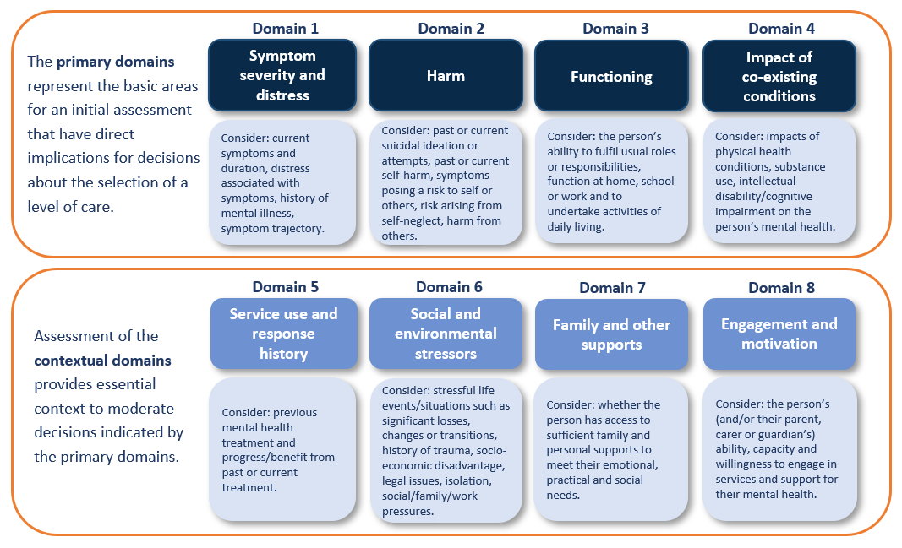
Initial assessment should consider the person’s situation across all 8 domains. The 8 domains, and factors covered in each domain, aim to capture key areas that a clinician should consider when determining the most appropriate services for a person needing a referral for a mental health intervention/service.
For each age group, the IAR domains include descriptors that provide examples of problems that could be present and are indicative of each severity level (there are five severity levels: no problem in this domain, mild, moderate, severe, or very severe problem in this domain). The descriptors provided are examples only, not an exhaustive list of all factors relevant to the domain. The descriptors at each severity level are differentiated by several factors, including the size or magnitude of the symptoms being experienced, the recency and frequency of occurrence of the symptoms and the pervasiveness of the impact of the symptoms on areas of the person’s life.
The 8 domains are consistent across the IAR rating guides for use with children, adolescent, adults, and older adults, as are the rating scales applied to each domain. However, the descriptors for each rating scale include specific differences based on the differences in development, environment, and context across the lifespan. The descriptors have also been adjusted to consider the lower tolerance for risk in children and adolescents and differences in the way mental health symptoms and psychological distress present across the lifespan.
Underpinning each of the domains is the concept of relative importance and severity – some factors within each domain are more important than others, and some domains (i.e., the primary domains) are more critical in the overall assessment of an individual’s need for a given level of care. While the relative importance of each domain may vary for each patient, an overall judgement is needed that requires decisions to be made about the severity of presenting problems within each domain.
An individual’s presenting problems on each domain can interact in different ways. For example, a person presenting with mild to moderate symptoms but no significant problems on any of the contextual domains (domains 5-8) may require a different level of care from one with mild to moderate symptoms but extensive social and environmental stressors or a poor response to previous treatment.
Detailed information on the 8 domains and rating each domain for children, adolescents, adults, and older adults is contained in the IAR Assessment Domains and Rating Guide for each age group, available as follows:
- Part B - Children (aged 5-11)
- Part C - Adolescents (aged 12-17)
- Part D – Adults (aged 18-64)
- Part E – Older Adults (aged 65 and over)

The IAR levels of care
The IAR assists health professionals to determine the most appropriate level of mental health treatment or intervention (i.e., mental healthcare) for a person with mental health symptoms and/or psychological distress. As noted in the introduction to this Guidance, some people experiencing mental health symptoms and/or psychological distress may need a package of services to meet their needs, including lower intensity mental health services, community support services and informal supports from friends and family. Community support services include psychosocial support services and other supports provided outside the health system, such as peer support, financial, housing, and social supports.
The IAR levels of care definitions only apply to mental health treatment/intervention services. However, it is often the case that those with more complex mental health needs also require more intensive community supports, many of which are provided outside the health system, for example financial, housing, family violence support. Health professionals and service providers should use their clinical judgement and knowledge of local services to discuss appropriate options for support with the patient.
This section describes the IAR five different levels of care that are consistent with the application and understanding of the stepped care model in the Australian primary care system. The information gathered through the initial assessment is used to recommend a level of care and inform a referral decision. The levels of care do not replace individualised assessment and care - instead, they provide a framework to guide decision-making.
It is important to emphasise that the descriptions of care at each level are offered only to guide judgements about the recommended level of care. Each presenting person, parent/caregiver, and family will have unique requirements that must always take precedence in decision-making.
There are five levels of care (depicted in Figure 2). Each level of care is differentiated based on the intensity of the mental health treatment/intervention available at each level of care. Figure 2 shows that psychosocial and community support needs may exist at any level of care, but typically increase as the mental health need increases. The availability and suitability of psychosocial and community supports is impacted by the person’s individual needs and the intake/eligibility criteria in place for such supports. For example, government funded psychosocial support programs tend to be targeted towards people with severe and/or complex mental health needs (i.e., people who tend to need IAR Level 4 or 5 mental health services).
Grouping the complex system of mental health services available in Australia into five levels is a convenient framework to think about stepped care rather than implying that there is a natural division of service types into neatly tiered categories. While some services are associated with a single level of care, most contribute to multiple levels. For example, GP mental health care can be associated with lower levels of care when it is provided in isolation, or higher levels when delivered in combination with other services or interventions (e.g., services delivered by a psychologist or psychiatrist, or multidisciplinary team).

Figure 2: the 5 IAR levels of care and mental health and community support needs
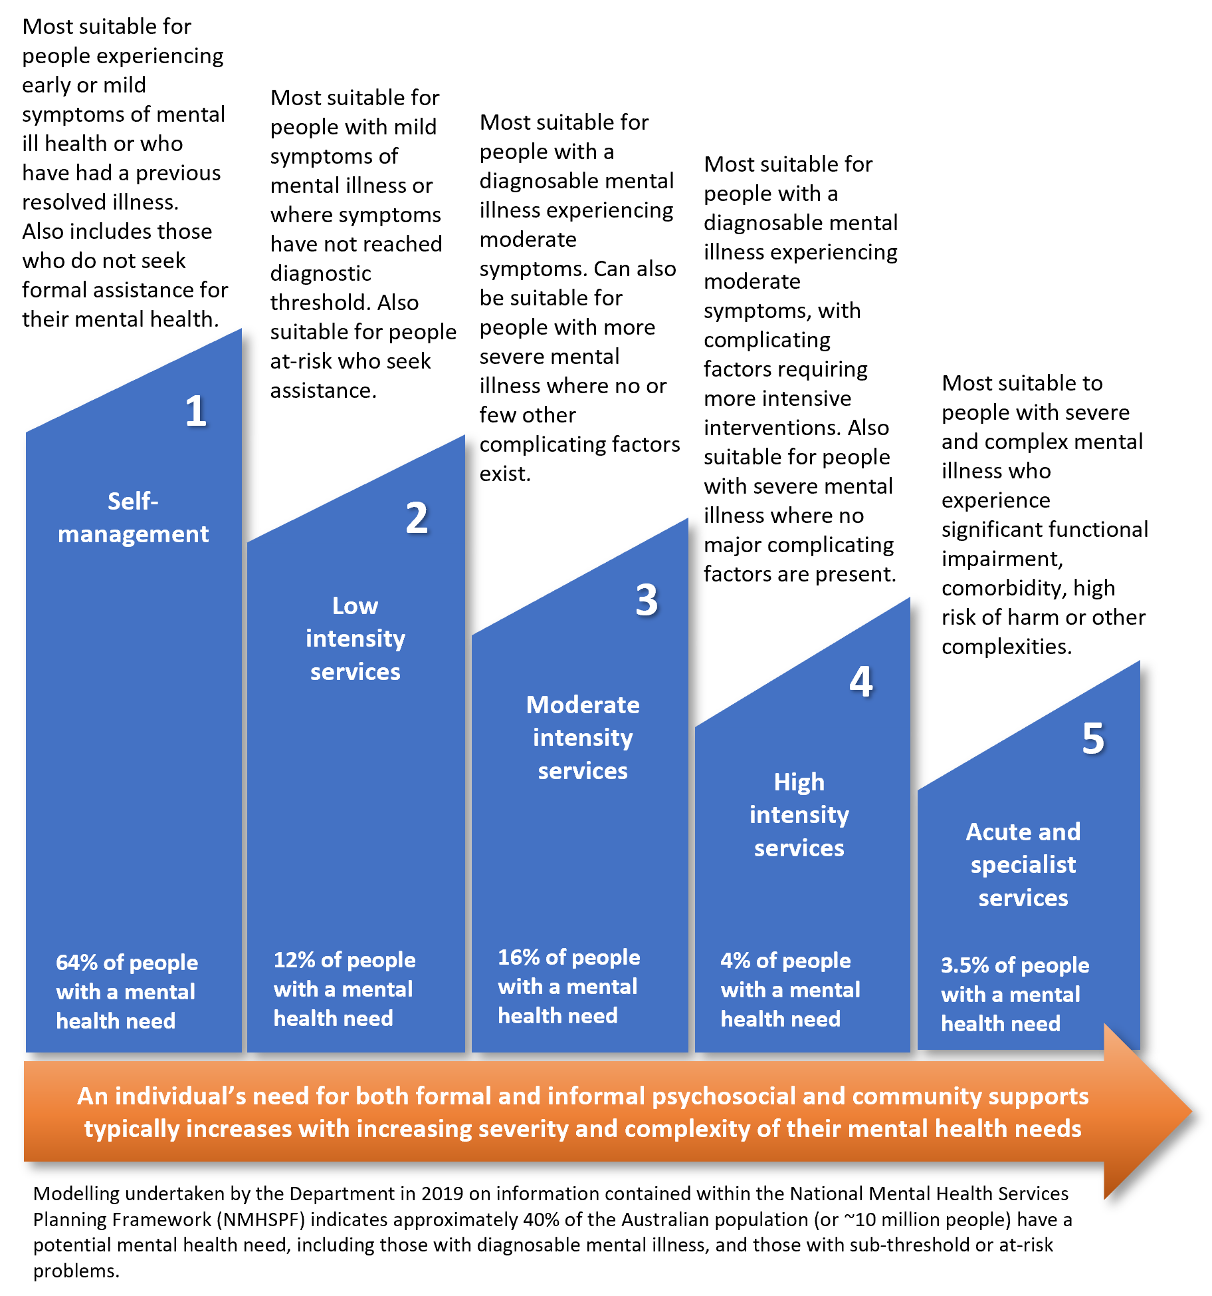
There may be a gap in services available at some or all levels of care in different regions and patient preference for one type of care over another. The determination of the most appropriate level of care a person requires applies irrespective of service availability, but referrers may need to take a flexible approach to best meet the needs of the patient (e.g., starting with a service the patient is comfortable to access before progressing to a different service when the patient is ready, utilising remote or telehealth delivered services or bundling services from across the levels of care as part of a care package). For example, a person requiring moderate-intensity intervention (Level 3) may also access resources more commonly associated with Level 1 (self-management) or Level 2 (low intensity) to complement or augment their care package.
Availability of services at each level of care will vary from region to region depending on factors such as funding and workforce distribution.
The detailed descriptions of the levels of care do not name specific services or providers, rather the type of services at each level are described along with the care environment and mental health interventions typically delivered at this level of care. A description of the person typically suited to this level of care is provided but should not override clinical judgement about the most appropriate service or services each person requires. Discussions about referrals and service options should include exploration of the individual’s circumstances, perspectives and preferences and may include consideration of:
- The readiness to engage in services and priorities of the person.
- The financial cost of services and the person’s ability to meet these.
- The location of the services and the person’s ability to attend.
- Culturally appropriate and safe services (such as social and emotional well-being services available through Aboriginal Community Controlled Health Organisations) and/or availability of in-language, interpreter, and translator services.
- The persons’ experiences of trauma, including family violence, history of persecution, imprisonment or forced relocation or removal from family or country, and experiences of racism, discrimination, or harassment.
- Developmentally appropriate services.
- The practical and emotional support needs of the person, including literacy, digital literacy, and access to technology for online services.
- The person's preferences relating to cultural, spiritual, and religious supports and services.
- Availability of services specific to the person's diagnosis (where applicable).
- Specialist sexuality and gender diversity resources and services.
- Options for integrated services and service models when the person has multiple conditions or needs.
Practice point – involving the patient and carer in decision-making
Supported decision-making strategies for initial assessment and referral:
- Ensure the patient and their carer is provided with information using their preferred way of receiving information (e.g., written/verbal/visual, English/other languages, with/without a support person). Take care to provide information that is age, developmentally and culturally appropriate, particularly when engaging with children and adolescents.
- Ensure the patient and their carer is provided with information about the range of services and support available (including the option of no service) and encourage the person to contribute their options, ideas, solutions, and expectations. This might include culturally important activities or self-care strategies.
- Ensure the patient and their carer can express concerns or fears about the options (e.g., cost, travel, previous positive or negative experiences).
- Be prepared to discuss each option's pros and cons (e.g., intensity, length of service engagement, commitment required, waiting periods, and the potential impact on symptoms).
- Check-in/follow-up to ensure the patient and their carer understands the information provided and ensure enough time for any questions.

Level 1 - Self-Management:

Definition:
This level of care generally involves accessing evidence-informed, appropriate, and culturally safe resources and other forms of self-help. For children and some adolescents, the resources may be targeted at parents/caregivers and other key supports (including teachers) to support the child or adolescent in managing any distress or symptoms and maintaining functioning without the direct involvement or support of a mental health professional or service. Where resources are directed at a child or adolescent, they may require considerable parent/caregiver assistance and encouragement to engage with and understand self-management recommendations.
Self-management resources and activities are not limited to online resources but also include attending a self-management activity in person (e.g., an information or education session), reading a printed resource, listening to audio tracks and podcasts, and watching a recording or video, etc. Resources can be focused on addressing current mental health symptoms or distress, preventing the onset of symptoms, or enhancing and maintaining wellbeing.
Children, adolescents, older adults, and other people may require assistance, prompting, and encouragement from a support person, caregiver, or family member to engage with and understand self-management recommendations, particularly if resources are hosted online and the person is not familiar with navigating websites. Assistance to access, print or listen to the resource or attend a self-management activity may be required.
Resources that promote positive child mental health are also likely to be appropriate (e.g., resources focused on warm and responsive parenting and creating a positive environment for infant and child brain development).

Care environment:
Self-management resources are easily accessible and available online, via telephone, in written or audio form, or in the community. Generally, people requiring Level 1 care alone may not seek out assistance with mental health symptoms or psychological distress in primary care. The person may present for assistance with difficulty sleeping, managing stress, maintaining healthy behaviours, or parenting for example. If so, this provides an opportunity for interventions aimed at promoting wellbeing, preventing illness, and intervening early to prevent escalation in difficulties.
Self-management resources can be made available and more easily accessible in integrated settings (e.g., child and family centres, educational and vocational settings, community centres, aged care services, pharmacies, and general practice).

Core mental health treatment/intervention services:
If a person does present to primary care and requires Level 1 care, this care is typically focused on encouraging and guiding the person to access high quality information, resources, and self-guided programs. The person can then access those resources themselves, or with the assistance of their parent or caregiver, but may also include facilitating access to support from another person/people (e.g., providing information to the person’s school or support worker).
Mental health treatment/intervention services at Level 1 include:
- Psychoeducation (written and verbal forms) and information via a GP or pharmacist for the person and their parent/caregiver.
- Self-guided mental health programs (which tend to be online, in books or “how to” guides or in group format) focused on promoting positive wellbeing, preventing difficulties, and acting early on signs of stress, distress or deteriorating mental health. Positive parenting programs are also included.
- Regular monitoring, with the capability to step up into a higher level of care if required.

Other health services that may be required:
A comprehensive physical health assessment and ongoing integrated management of physical health issues via a GP.
Health promotion, lifestyle interventions and social prescribing (e.g., sleep hygiene, social exercise programs).

Support services:
Community, social, leisure, and recreational supports aimed at enhancing protective factors and minimising risk factors for mental health and wellbeing.
Supports targeting situational stressors, such as housing, legal support, financial support, relationship counselling parental/family focused education and support, and support for grief and loss.
Formal and informal individual and group peer support for the person or their parent/caregiver (including online peer support forums and chats).
Services and support focussed on connections with community and culture.
Care coordination services, service navigation, and advocacy.

Referral criteria:
A person suitable for this level of care typically has minimal or no concerns relating to harm and is usually experiencing mild symptoms/low levels of distress. Where distress is present, this may be in response to a stressful environment or stressful event.
Symptoms have typically been present for a short time (less than three months for children and adolescents and less than six months for adults and older adults, but this may vary). The person is generally functioning well. Where the person has accessed services before, they are likely to have had a moderate to excellent response to the previous service experience.
A person struggling with motivation and engagement or who is experiencing other barriers to self-management (such as financial barriers, language barriers, transport barriers) should not be referred to this level of care if these barriers prevent the person from engaging in self-management strategies.

Level 2 - Low-Intensity Services

Definition:
Low-intensity services are evidence-based mental health treatment/intervention services designed to be accessed quickly (without the need for a formal referral, e.g., through a third-party service or provider), easily (through a range of modalities including face-to-face, group work, telephone, and online services) and typically involve few or short sessions or a specific manualised course or program of lessons/sessions designed to teach evidence-based strategies for managing symptoms of mental illness and/or distress.
In contrast to Level 1, low-intensity services include some level of direct, although brief, engagement with a qualified mental health professional or appropriately trained non-clinical workers (sometimes called therapists or coaches), under the supervision of a suitably qualified and experienced mental health professional.

Care environment:
Services are easily accessible and available online, over the telephone or face-to-face in the community. Services may also be available in community settings (e.g., schools, community centres, pharmacies, and general practice).

Core mental health treatment/intervention services:
Psychoeducation (written and verbal forms) and teaching of psychological strategies for managing mild to moderate symptoms of mental illness or distress.
Online clinician/therapist/coach assisted programs and courses designed to treat a mild to moderate mental health disorder or psychological distress.
Brief telephone and face-to-face psychological services delivered by GPs, paediatricians, and mental health professionals. Includes both individual and group work.
For children and young people, services focused on supporting parents/caregivers to implement evidence-based parenting strategies for managing mild presentations of concerning behaviours or social and emotional disturbances in children and adolescents, and for supporting positive child and adolescent development.
For older people, may include brief intervention services from professionals specialising in ageing such as geriatricians.

Other health services that may be required:
A comprehensive physical health assessment and ongoing integrated management of physical health issues via a GP.
Health promotion, lifestyle interventions and social prescribing (e.g., sleep hygiene, social exercise programs).

Support services:
Specific community, social, leisure, and recreational supports aimed at enhancing protective factors and minimising risk factors for mental health and wellbeing.
Accommodations and supports to minimise impacts of mental health symptoms and psychological distress on functioning and/or to reduce impacts of stressors that may exacerbate symptoms or distress, including supports or accommodations at school or work.
Supports targeting situational stressors, such as housing, legal support, financial support, relationship counselling parental/family focused education and support, and support for grief and loss.
Formal and informal individual and group peer support for the person or their parent/caregiver (including online peer support forums and chats).
Services and support focussed on connections with community and culture.
Care coordination services, service navigation, and advocacy.

Referral criteria:
A person suitable for this level of care typically has low or no concerns relating to harm and is usually experiencing mild symptoms/low levels of distress. Symptoms have typically been present for a short time (less than three months for children and adolescents and less than six months for adults and older adults, but this may vary). The person is generally experiencing only minor impacts on functioning due to mental health symptoms or distress, but may be struggling with motivation or engagement or, particularly for children and adolescents, may have limited/minimal/no family or other supports – both of which contraindicate a referral to Level 1 care.
Complexity indicated by significant problems in Harm, Functioning or Co-existing Conditions should be considered contraindications for referral to Level 2 care and trigger a referral to Level 3 or higher.

Level 3 – Moderate-Intensity Services

Definition:
Moderate-intensity services generally provide a course (or repeated courses) of structured, reasonably frequent, and individually tailored treatment/intervention for mental health symptoms and psychological distress (e.g., a defined number of regular psychological sessions). Access to level 3 services typically requires a referral from a GP or mental health professional.

Care environment:
Moderate-intensity services are typically provided by mental health professionals in community settings and can be face-to-face or via telehealth (or a blend of the two) and delivered to individuals or groups. Some online treatment programs or courses that are accompanied by regular and tailored support delivered by a qualified mental health professional may be considered a Level 3 service. Services may sometimes be available in integrated settings (e.g., schools, community centres, and general practice).

Core mental health treatment/intervention services:
A comprehensive biopsychosocial assessment (if not already undertaken) is recommended for all people suited to this level of care. This may be done as part of the initial assessment when the person presents to primary care with mental health symptoms and/or psychological distress or may occur at the service the person is referred to for assessment and/or intervention.
This level of care typically includes the involvement and coordination of more than one service provider, such as a GP providing initial assessment and care coordination and a mental health professional (such as a psychologist or psychiatrist) delivering mental health treatment.
Evidence-informed, appropriate, and culturally safe psychological services delivered by a suitably qualified and experienced mental health professional (note, psychoeducation is usually a part of services delivered, but is not considered a level 3 service on its own).
Specialist mental health services (including consultation or management by a psychiatrist or state-based mental health team) for assessment, management, consultation liaison, and advice if needed and in accordance with local assessment and care pathways.
Diagnosis-specific services where indicated.

Other health services that may be required:
A comprehensive physical health assessment and ongoing integrated management of physical health issues via a GP and/or paediatrician or geriatrician.
Health promotion, lifestyle interventions and social prescribing (e.g., sleep hygiene, social exercise programs).

Support services:
Additional services are likely to be needed and may include:
- Accommodations and supports to minimise impacts of mental health symptoms and psychological distress on functioning and/or to reduce impacts of stressors that may exacerbate symptoms or distress, including supports or accommodations at school or work.
- Specific community, social, leisure, and recreational supports aimed at addressing factors that may be contributing to the onset or maintenance of the persons mental health symptoms or distress.
- Supports targeting situational stressors, such as housing, legal support, financial support, relationship counselling, parental/family focused education and support, and support for grief and loss.
- Formal and informal individual and group peer support for the person or their parent/caregiver (including online peer support forums and chats).
- Services and support focussed on connections with community and culture.
- Care coordination services, service navigation, and advocacy.

Referral criteria:
A person requiring this level of care is likely to be experiencing moderate to severe symptoms and distress that would meet the criteria for a mental health diagnosis. Symptoms have typically been present for three months for children and adolescents or six months or more for adults and older adults (but this may vary).
The initial assessment may indicate problems (but not very severe) present in domain 1 – symptom severity and distress, domain 2 - harm, domain 3 - functioning or domain 4 - impact of co-existing conditions (a very severe rating on domains 1, 2 or 3 would trigger consideration of a referral to Level 5).
People experiencing moderate to severe mental health symptoms but mild to moderate problems associated with domain 2 - harm, domain 3 – functioning, and domain 4 - impact of co-existing conditions are usually suitable for this level of care.

Level 4 – High-Intensity Services

Definition:
High-intensity services include periods of intensive service that usually involve multi-disciplinary support and care coordination as multiple services are likely to be involved. Services may need to be provided over a long period of time or periodically as a person’s mental health fluctuates. Level 4 is usually designed to support people experiencing severe symptoms (domain 1), significant functional impairment (domain 3), or significant concerns about harm (domain 2).

Care environment:
High-intensity services are typically provided by mental health professionals in community settings but can also be delivered in hospital or via hospital out-patient programs (usually voluntary programs). This service level can also include outreach to the person within their home or another environment (e.g., school, community services and general practice).

Core mental health treatment/intervention services:
A comprehensive biopsychosocial assessment (if not already undertaken) is recommended for all people suited to this level of care. This may be done as part of the initial assessment when the person presents to primary care with mental health symptoms and/or psychological distress or may occur at the service the person is referred to for assessment and/or intervention.
As noted above, services at this level typically involve multi-disciplinary support and care coordination as multiple services are likely to be involved. Care coordination may be managed by the GP, psychiatrist, paediatrician, or state-based community mental health team.
Evidence-informed, appropriate, and culturally safe psychological services delivered by a suitably qualified and experienced mental health professional.
Psychiatric opinion, referral, management, including medication management, and/or treatment.
Specialist mental health services (including consultation or management by a psychiatrist or state-based mental health team) for assessment, management, consultation liaison, and advice if needed and in accordance with local assessment and care pathways.
May include periods of in-patient or out-patient hospital services.
Diagnosis-specific services where indicated.

Other health services that may be required:
A comprehensive physical health assessment and ongoing integrated management of physical health issues via a GP and/or paediatrician or geriatrician.
Health promotion, lifestyle interventions and social prescribing (e.g., sleep hygiene, social exercise programs).

Support services:
Additional services are likely to be needed and may include:
- Specific community, social, leisure, and recreational supports aimed at addressing factors that may be contributing to the onset or maintenance of the person’s mental health symptoms or distress or that the person may experience difficulty with due to their mental health, such services to help people manage daily activities, rebuild, and maintain connections, build social skills and participate in education and employment.
- Accommodations and supports to minimise impacts of mental health symptoms and psychological distress on functioning and/or to reduce impacts of stressors that may exacerbate symptoms or distress, including supports or accommodations at school or work.
- Supports targeting situational stressors, such as housing, legal support, financial support, relationship counselling, parental/family focused education and support, and support for grief and loss.
- Formal and informal individual and group peer support for the person or their parent/caregiver (including online peer support forums and chats).
- Services and support focussed on connections with community and culture.
- Care coordination services, service navigation, and advocacy.

Referral criteria:
A person requiring this level of care usually has severe symptoms. A person with a severe presentation is likely to be experiencing moderate or higher problems associated with domain 2 - harm,
domain 3 -–functioning, and domain 4 - impact of co-existing conditions. Where problems are assessed as very severe in domain 1 - symptom severity and distress, domain 2 - harm, and domain 3 - functioning, a referral to Level 5 care should be considered.

Level 5 - Acute and Specialist Community Mental Health Services

Definition:
Specialist mental healthcare usually includes intensive team-based specialist assessment and service (typically state/territory mental health services) with involvement from a range of different mental health professionals, including case managers, psychiatrists, social workers, occupational therapists, psychologists and drug and alcohol workers. This level also often includes more intensive care provided by GPs working with acute and specialist teams.

Care environment:
Ideally, Level 5 services are delivered in the community with outreach to the person within their home or another environment. This level may also involve specialist mental health inpatient and outpatient care within a hospital environment, community-based intermediate care, sub-acute unit, or crisis respite centre.

Core mental health treatment/intervention services:
For this level of care, the person will likely benefit from psychiatric assessment and care, specialist behavioural programs, crisis management, and therapeutic services using pro-active engagement strategies provided by a multi-disciplinary specialist team with outreach capability.

Other health services that may be required:
A comprehensive physical health assessment and ongoing integrated management of physical health issues via a GP may also be required.

Support services:
Additional services are likely to be needed and may include:
- Specific community, social, leisure, and recreational supports aimed at addressing factors that may be contributing to the onset or maintenance of the persons mental health symptoms or distress or that the person may experience difficulty with due to their mental health, such services to help people manage daily activities, rebuild, and maintain connections, build social skills and participate in education and employment.
- Accommodations and supports to minimise impacts of mental health symptoms and psychological distress on functioning and/or to reduce impacts of stressors that may exacerbate symptoms or distress, including supports or accommodations at school or work.
- Supports targeting situational stressors, such as housing, legal support, financial support, relationship counselling, parental/family focused education and support, and support for grief and loss.
- Formal and informal individual and group peer support for the person or their parent/caregiver (including online peer support forums and chats).
- Services and support focussed on connections with community and culture.
- Care coordination services, service navigation, and advocacy.

Referral criteria:
A person requiring this level of care usually has severe or very severe mental health symptoms, with associated behaviours that are likely to present an imminent or unpredictable danger to self or others and severe problems in functioning across multiple or most everyday roles (work, education, parenting, volunteering), or is experiencing:
- Very significant concerns about suicide, self-harm, or engagement in high-risk behaviours or activities.
- Very significant concerns about harm to others.
- Extremely compromised self-care ability to the extent that there is a real and present danger of the person experiencing harm related to these deficits.

Guiding Principles for initial assessment and referral
The following principles underpin high-quality initial assessment and referral practices and should be incorporated when using the IAR.

Supported decision-making and consumer choice
Supported decision-making is enhanced when a clinician offers knowledge and information about what evidence-based interventions are likely to be of benefit and communicates the risks associated with each treatment option (including the risks associated with no treatment) and the outcome probabilities. The consumer, in turn, contributes expertise in their clinical and social experiences, values, preferences, circumstances, and barriers. Carers, family members, and significant others may also have insights and add significant value when actively engaged and encouraged to participate as partners in the decision-making process. Within supported decision-making frameworks, there is inherent respect and appreciation for the perspectives of consumers, carers, and clinicians alike.
The Australian Healthcare Charter of Rights emphasises the rights all people have, including the right to a genuine partnership with their healthcare providers and to:
- ask questions and be involved in open and honest communication,
- make decisions with their healthcare provider to the extent that they choose and are able to, and
- include the people that they want in planning and decision-making.
Users of the IAR are expected to protect and uphold the individual's right to express a choice and preference in their healthcare and be active partners in decision-making.

Trauma-informed initial assessment and referral practices
There is no universally accepted definition of trauma-informed care, however, the definition of trauma-informed approaches provided by Substance Abuse and Mental Health Services Administration (SAMHSA) in the USA is commonly used in Australia. Trauma “results from an event, series of events, or set of circumstances that is experienced by an individual as physically or emotionally harmful or life threatening and that has lasting adverse effects on the individual’s functioning and mental, physical, social, emotional, or spiritual well-being” .
A trauma-informed approach to mental health services is based on the understanding and expectation that people using services (and people working in services) may have experienced trauma. It recognises that each person’s experience and expression of trauma is unique and can affect people in many ways, including physical, emotional, psychological, behavioural, social, and interpersonal impacts. Trauma-informed services integrate knowledge about trauma into policies, procedures and practices and seeks to ensure the service experience will not cause further trauma, harm, or distress. Trauma-informed care incorporates the principles of safety, including cultural safety, collaboration, transparency, trustworthiness, and supported decision-making (choice, control, autonomy, and empowerment) into all parts of a service. It recognises that trauma related symptoms and behaviours originate as ways to manage and survive the traumatic experience. Surviving a trauma experience is a strength and demonstrates resilience, and the trauma survivor’s experience should be respected and validated.

Least treatment burden for best outcome
The IAR aims to minimise the intrusiveness and intensity of the initial assessment process wherever possible by limiting the number and length of initial assessments and minimising re-assessment where it is clinically appropriate.
Intervention recommendations for each level of care are based on the least intensive and least intrusive evidence-based intervention that will lead to the most significant gain. Observing this principle is likely to increase consumer participation in treatment.

Accessible care options
An individual is more likely to engage in an intervention that is easy to access, flexible and affordable. The IAR Guidance promotes initial assessment and referral that is sensitive to the individual’s needs, preferences, and capacity. Barriers to accessing services, including financial capacity, distance, mobility, transport etc, should be considered and addressed (where possible) when identifying appropriate services for people.

Responsive and flexible
People's clinical needs can change over time, and in well-functioning stepped care systems, services use routine outcome monitoring and consumer feedback to change the intervention as needed. Subsequently, services respond by increasing or decreasing service intensity or varying the type or number of services provided. This ideally happens seamlessly, without requiring re-referral and re-entry to the system (including where a consumer has been discharged). As changes are made to the intervention, there should be timely communication with the patient, the original referrer and any other clinicians involved in their care.

Effective clinical governance and safety
A high-performing initial assessment and referral system is underpinned by robust clinical governance and structures, policies and procedures that protect people from harm and improve the quality of health service provision. Service providers, commissioners and funders of services should ensure that service models, processes and procedures adhere to relevant healthcare standards, regulation and accreditation schemes and should refer to the Australian Commission on Safety and Quality in Health Care and Commonwealth, State and Territory legislation for guidance.

Progress Monitoring and Review
Across all age groups and levels of care, progress monitoring is essential. Research indicates that progress monitoring improves outcomes by detecting when an individual is not improving or is deteriorating under the intervention and this information is shared with the individual. This process lends itself to changes to the care plan or approach used, leading to a more flexible and responsive intervention.
Progress monitoring also helps ensure that the intervention commenced/continued as planned and is an objective way of ascertaining if the intervention successfully reduces symptoms and improves functioning.
Progress monitoring can be conducted via follow-up consultations and may include the use of outcome measures/tools to measure progress. In the initial stages of treatment, it may be too early to determine clinical benefit. However, early signs of clinical deterioration or worsening are possible and should be checked. Equally, if the person’s symptoms and mental health have improved, they may benefit from stepping down to a lower level of care.
If a change in service type or intensity is required, the initial assessment usually does not need to be repeated in full, but rather the changed circumstances explored.
The IAR has not been developed as a tool for progress monitoring or review and is not necessarily sensitive enough to be helpful. Clinicians may choose to adjust their ratings and recalculate the level of care recommended by the IAR and consider this when making a clinical decision about the best level of care the patient now requires.
Practice point – routine monitoring
Regular review of a consumer’s progress is ideally built into the intervention to capture new information that becomes available, so that individuals requiring a higher level of care, are stepped up speedily and efficiently, or stepped down if a lower level of care is now required. To facilitate this process, health and social outcomes should be routinely and regularly recorded and shared with the consumer. There is emerging evidence that routine outcome measures, collected on a session-by-session basis, provides the level of information necessary to guide timely 'step up' or 'step down' decisions and can improve the effectiveness of the intervention.

The IAR decision support tool logic
In mental healthcare, complex decisions are made daily based on evidence drawn from various sources. The same process is applied to referral decisions, where the referring practitioner must consider the person’s mental health needs, consider their circumstances, choices, and preferences, and guide them to the best available referral option. Many clinicians undertake this process in a global way that is not usually broken down into step-by-step decision-making.
The approach used in the IAR aims to unpack the referral decision process into its component parts and describe a logic for determining the recommended level of care for a person presenting for assistance with a mental health problem.
Assessment on the 8 domains provides a starting point. The next step is to define levels of care based on different levels of resource intensity. The IAR Guidance outlines the schema for conceptualising resource intensity based on five levels of care in a stepped care model. The model guides thinking about referral options rather than a picture-perfect reflection of the mental health service system.
The third and final step concerns the ‘bridge’ between assessing a presenting individual on the domains and considering a recommended level of care. Each person will present with a unique set of circumstances, such that arbitrary and inflexible rules that apply to all are inappropriate. The assessment domains are interactive with the implication that a decision about the goodness of fit between the person’s intensity of needs and referral to a level of care needs to consider all assessed domains and their component factors in combination.
A person’s presenting issues on each domain can interact in different ways. As an example, a person presenting with mild to moderate symptoms (Domain 1) but no significant problems on any of the contextual domains (domains 5-8) is likely to require a different level of care from a person with mild to moderate symptoms but extensive social and environmental stressors or a history of poor response to previous treatment.

Figure 3: Mapping assessments on 8 interactive domains to 5 levels of care
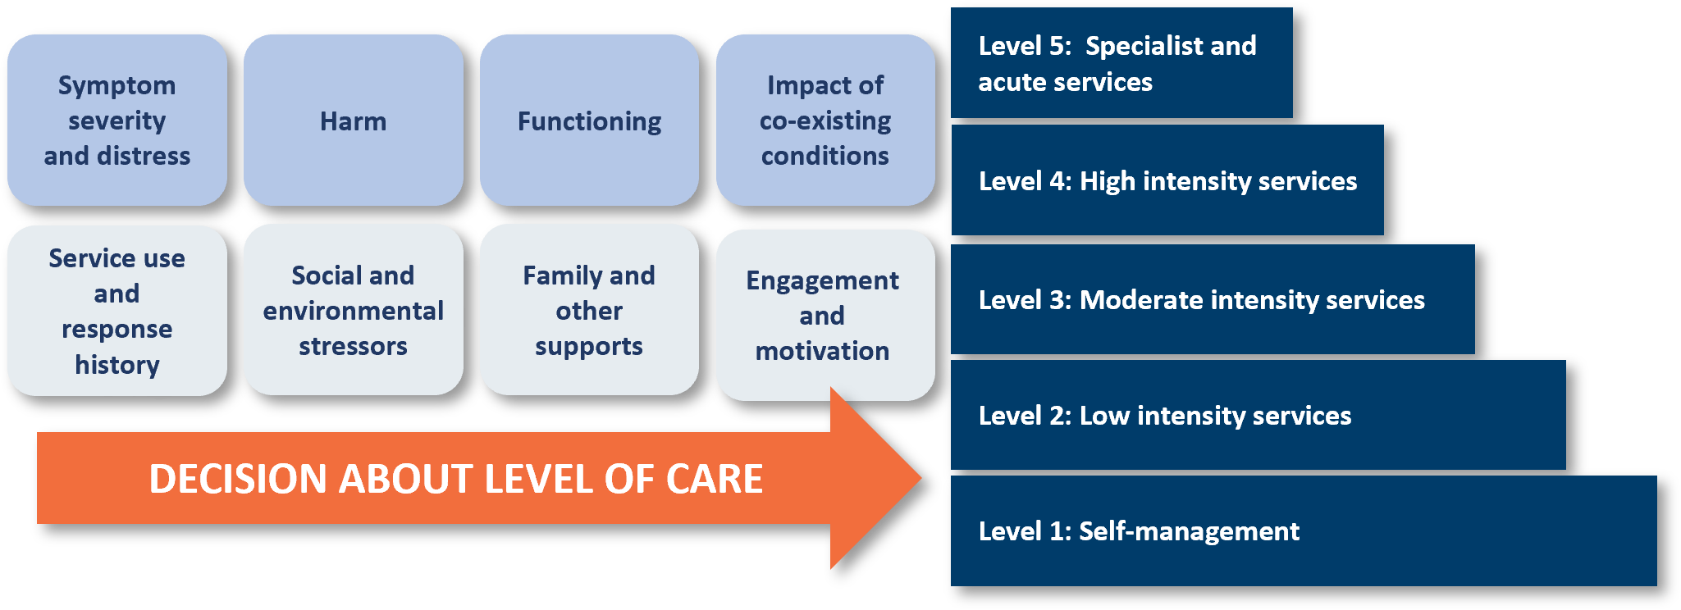

The figures below summarise the logic that underpins the IAR-DST. The logic for children and adolescents differs from the logic for adults and older adults and can be seen in the orange diamonds in the centre of both logic diagrams. This difference reflects that there is:
- less tolerance for social and environmental stressors for children and adolescents, such that a rating of severe (3) or very severe (4) on domain 6 (social and environmental stressors) will result in an overall level of care of 2 or above, but a rating of very severe (4) is required for this pathway for adults and older adults.
- a requirement for children and adolescents to have at least limited or mixed supports (rating of 2 or less) on domain 7 (family and other supports) in addition to having optimal (rating of 0) or positive (rating of 1) engagement and motivation (domain 8) to be recommended a level of care of 1 (self-management).

The logic shows how ratings of the domains using the rating guide, and interactions between the domains, can be applied to guide referral decisions.
Like most decision support tools that aim to describe complex relationships, the initial impression for many who examine the logic may be that it is complex or difficult to fathom at first glance. However, there is an underlying simplicity to the approach to guiding decision-making described below by dissecting the clinical decision support tool into sections.
There are five levels of care and 11 possible pathways into the 5 levels of care. The 11 pathways are referenced using the black numbered circles.
Pathway 1: ‘red flag’ items are identified that would usually warrant referral to Level 5 care, including acute and specialist community mental health services (primarily state and territory services). These include very severe ratings on symptoms, risk, and functioning domains. ‘Red flag’ items act as independent criteria that automatically place an individual in a specific level of care, regardless of their assessment on other domains.
Pathways 2 – 5: targets people with relatively minor problems on primary domains. Decisions about the recommended level of care for this group are guided using treatment history (domain 5) and other contextual domains into (mostly) Level 1 or 2 care.
Pathways 6 – 11: There is considerable complexity in this potentially large group. Presentations in this group are classified initially based on symptom/distress severity, then on other complexity in the other primary domains. Levels of care are recommended for this group based on the contextual domains (and are not mapped in the logic diagrams). Most of this group are expected to be referred to Level 2 or above.

Figure 4: IAR-DST Logic for Children and Adolescents
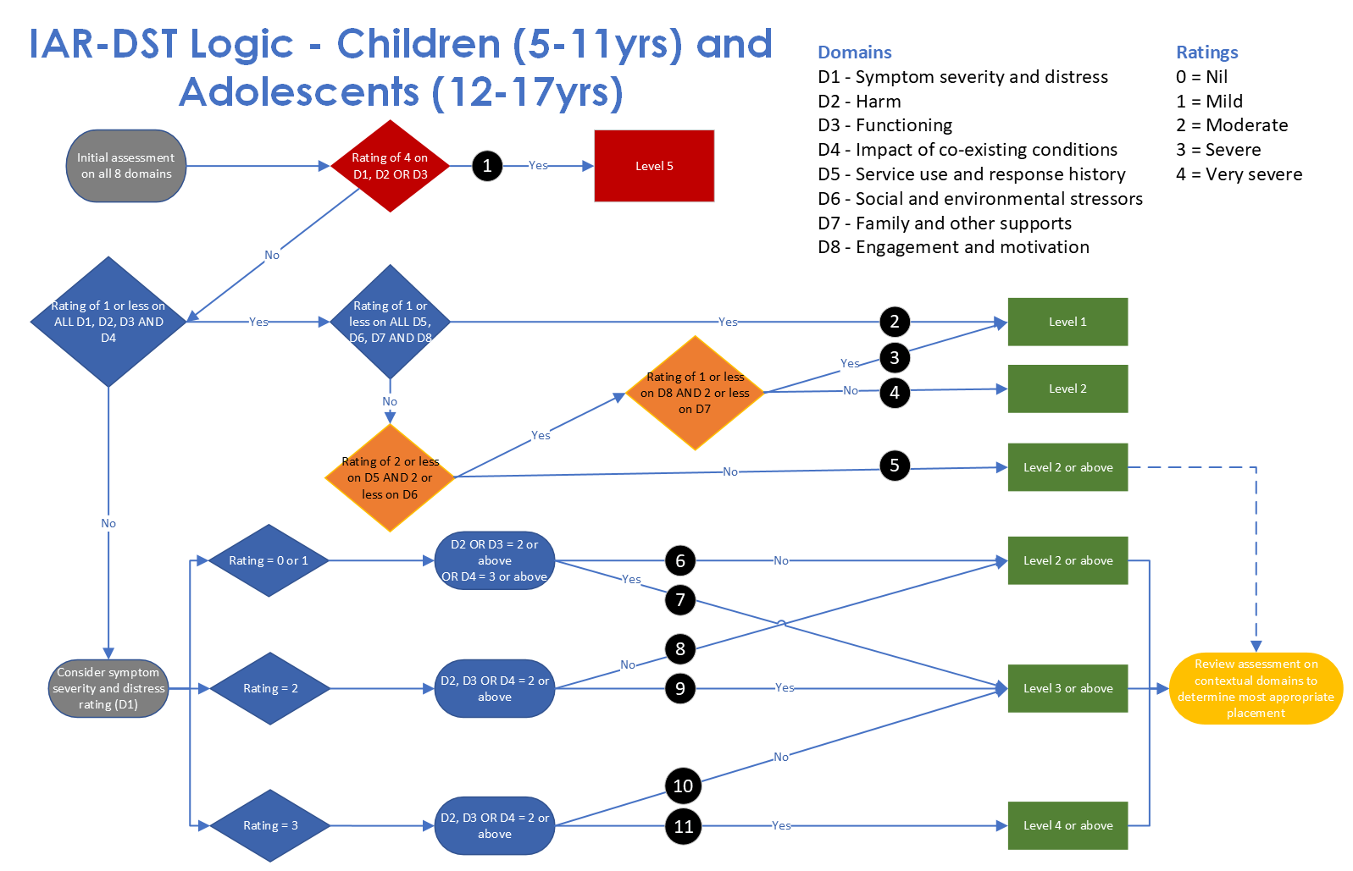

Figure 5: IAR-DST Logic for Adults and Older Adults
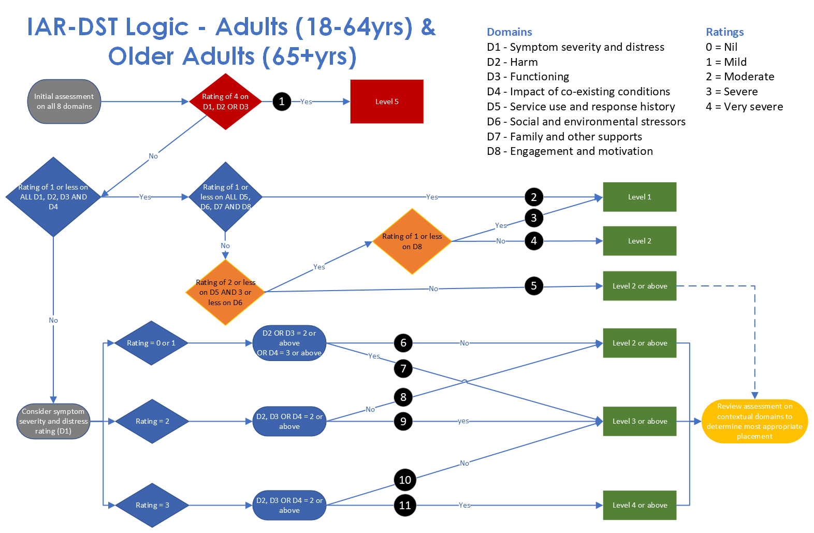

The online IAR tool
The online IAR decision support tool was developed to provide users with a simple, easy to navigate automation of the IAR logic. It enables a user to select a patient’s appropriate age group, enter ratings for each of the 8 domains and produce a recommended level of care for consideration, that can be saved and/or shared with the patient.

Accessing the online tool
The online Decision Support Tool and guidance is available at https://iar-dst.online/#/. Users are required to indicate acknowledgment and acceptance of the Terms of Use as a pre-requisite to accessing the tool. This will occur via a simple ‘click’ agreement process.

Key features of the online tool
This simple tool allows individual practitioners to enter the 8 domain ratings and view the derived level of care outcome online. The tool:
- Does not require the capture of any identifying information.
- Does not require authentication.
- Provides access to context sensitive help regarding the 8 domains.
- Processes the entered scores and presents the recommended level of care.
- Provides access to context sensitive help regarding the recommended level of care.
- Provides a responsive experience across devices from phones through to desktop computers.
- Allows the user to copy a CSV row of the domain scores to facilitate data collection into an existing spreadsheet.
- Allows download of a CSV file of the domain scores to facilitate data collection in a new spreadsheet.
- Allows the user to download and/or print a PDF of the patient’s Online Decision Support Tool recommended level of care, the clinician’s recommended level of care and information about the consumer which can be saved onto the consumer’s file.
- Meets Australian Government accessibility requirements.
- Meets Australian Government security requirements.

Integration of the online tool

Application Programming Interface (API)
The Department also provides an API for use by organisations wanting to easily integrate the IAR-DST into their own local systems. This mechanism is via a request over the internet to the API service from the organisation’s local system. The Online API:
- Does not require the capture of any identifying information other than the organisation making the request.
- Requires the integrator to use an API key linked to their organisation (an API key creates a linkage to the origin of the request).
- Allows submission of the 8 domain scores.
- Processes the entered scores and returns the recommended level of care.
- Meets Australian Government security requirements.

Reference Implementation and Test Data Set
The reference implementation has been developed as a software library. The library consumes the 8 domain scores and returns the derived recommended level of care via an implementation of the scoring algorithm.
Third-party developers can use the reference implementation to understand how best to create a local implementation of the scoring algorithm. This might be desirable where a different programming language to the one used in the reference implementation is a local requirement. It may also be integrated into local systems. This integration method does not require the integrator to send data to an external system over the internet. The reference implementation:
- Implements the scoring algorithm required to consume the 8 domain scores and return the recommended level of care,
- Includes documentation for developers,
- Includes examples of use, and
- Includes a test suite to ensure accuracy.
A test data set has been developed, covering many possible combinations of domain ratings and the associated derived level of care. The test data set may be used by third-party developers who wish to implement the scoring algorithm themselves.

Digital Decision Support Tools – Conditions of use
Users of the API and software library are required to agree to an ‘Integrator Agreement’ that sets out Terms of Use appropriate to their role. Further information is provided at Developer resources — IAR Decision Support Tool 1.05 documentation (iar-dst.online)

More information
Please contact the Department at MH.IARProject@Health.gov.au with questions or feedback about the IAR Guidance and IAR-DST.

The modelling examined the total population with a potential need, including those with diagnosable mental illness and those with sub-threshold or at-risk problems. This equates to 10 million people, or roughly 40% of the population, as described in the Guidance. The outcome of the modelling provides indicative estimates of how mental health needs in the population are spread across the 5 defined levels of care.
Substance Abuse and Mental Health Services Administration. SAMHSA’s Concept of Trauma and Guidance for a Trauma-Informed Approach. HHS Publication No. (SMA) 14-4884. Rockville, MD: Substance Abuse and Mental Health Services Administration, 2014.
Substance Abuse and Mental Health Services Administration. SAMHSA’s Concept of Trauma and Guidance for a Trauma-Informed Approach. HHS Publication No. (SMA) 14-4884. Rockville, MD: Substance Abuse and Mental Health Services Administration, 2014.

